
Company
Logotype

Cone Beam Computed Tomography- Report



Porur Dental X-rays & CBCT

Patient Name : Mrs. Divya | Date of Report : 11.04.2024
Age/ Gender : 26 years/ Female | Region of Interest : CBCT Sectional Maxilla
Referring doctor: Dr. P. Kumaresh | Indication : Impacted tooth
Clinical Notes: Nil
PATIENT INFORMATION

CBCT Sectional Maxilla provided
CBCT – IMAGE DETAILS

RADIOGRAPHIC INTERPRETATION

- Completely missing crown and root portion in relation to 27.
- The tooth 28 appears to be posteriorly placed, almost adjacent and in proximity to the inner aspect of ramus near lingula.
- The tooth 28 is positioned such that its crown is positioned in posterior aspect. Its root portion is positioned in anterior aspect adjacent to the left coronoid process.
- The impacted 28 lies in close proximity to the left lateral pterygoid plate.
- There is presence of an additional hyperdense bone spike like structure attached to the radicular portion of the impacted 28.
- Distance between the 28 and lateral pterygoid plate: 2.23 mm

RADIOGRAPHIC IMPRESSION


- Impacted tooth: 28.

IMAGES FOR REFERENCE

RECONSTRUCTED PANORAMIC VIEW
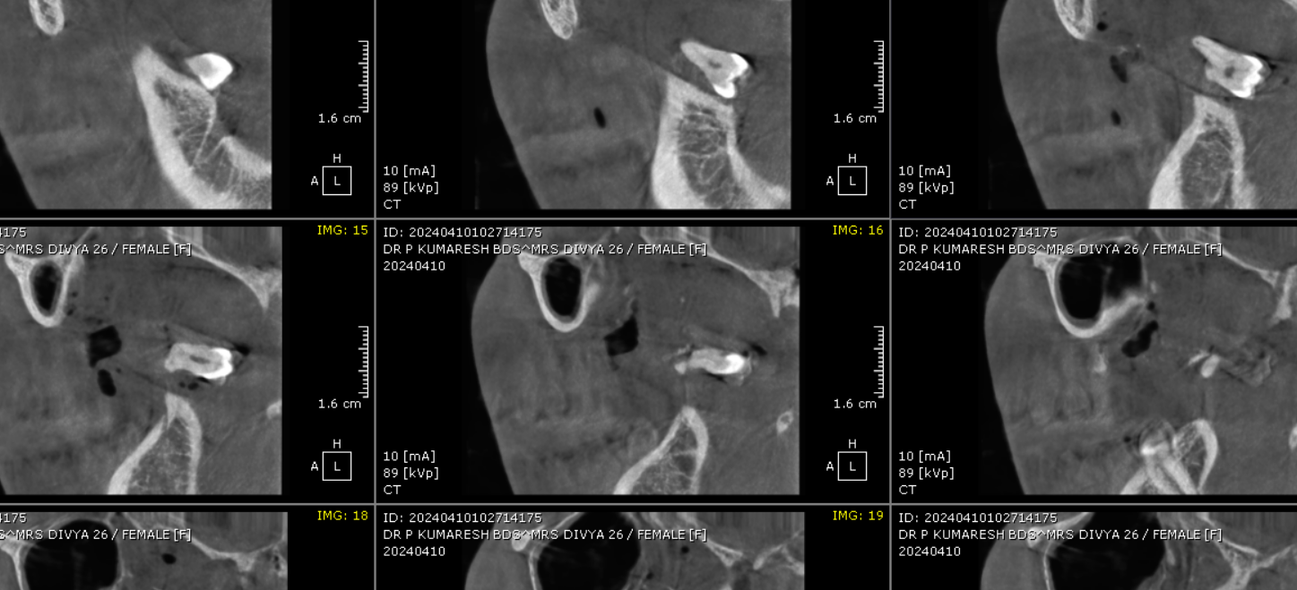
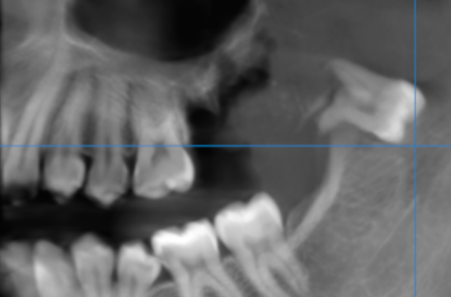
SAGITTAL SECTION

Impacted 28 and its proximity to lateral pterygoid plate- Coronal view | 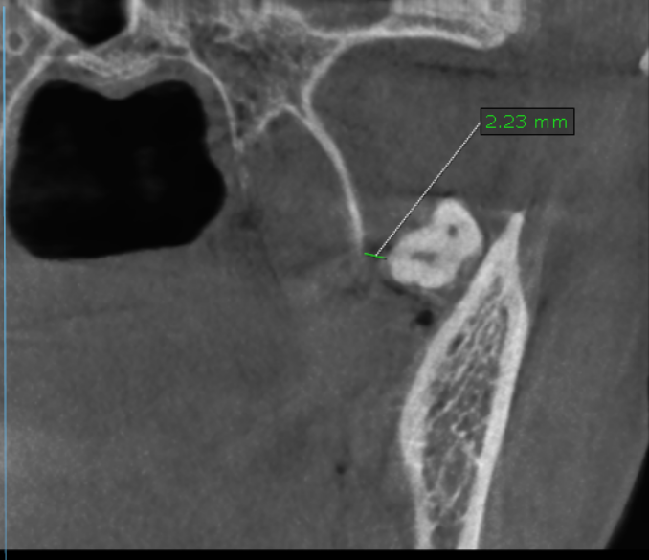
Cross- sectional image slices | 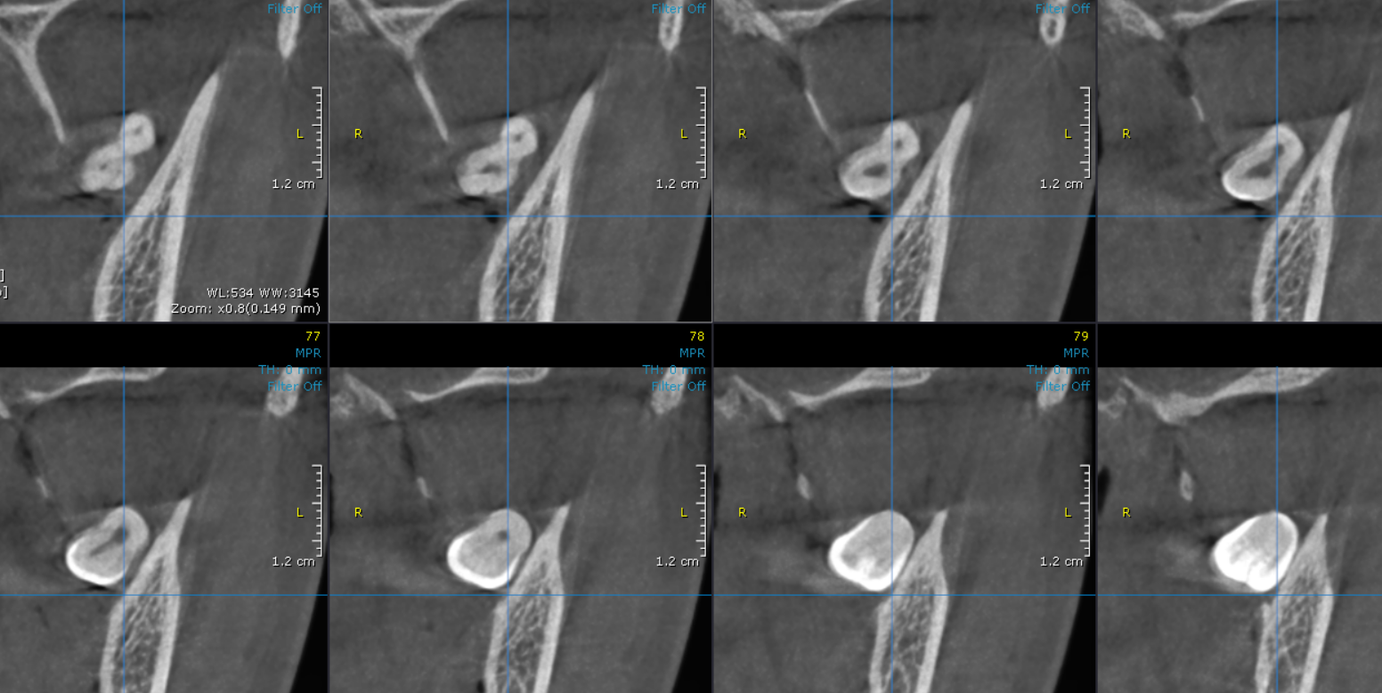

3-DIMENSIONAL VIEW
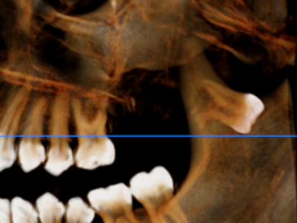

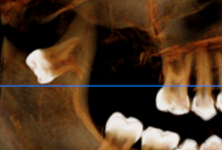
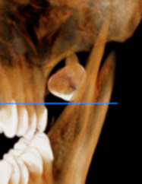

**** End of report ****

